GSS Session-5
dsde0222_gss_s5
Training Clarusway
Pear Deck - June 14, 2022 at 5:39PM

Part 1 - Summary
Use this space to summarize your thoughts on the lesson

Part 2 - Responses
Slide 1


Use this space to take notes:

Slide 2 | Your Response
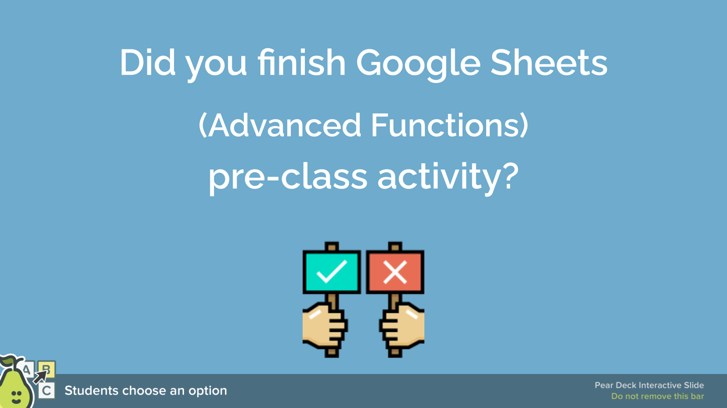 | You Chose  - Partially finished.  Other Choices  - Yes, I finished.  - No, I didn't finish.
Use this space to take notes:

Slide 3
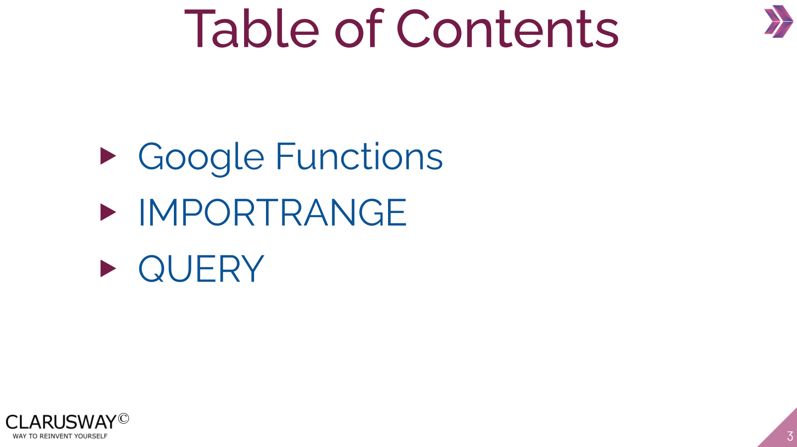

Use this space to take notes:

Slide 4
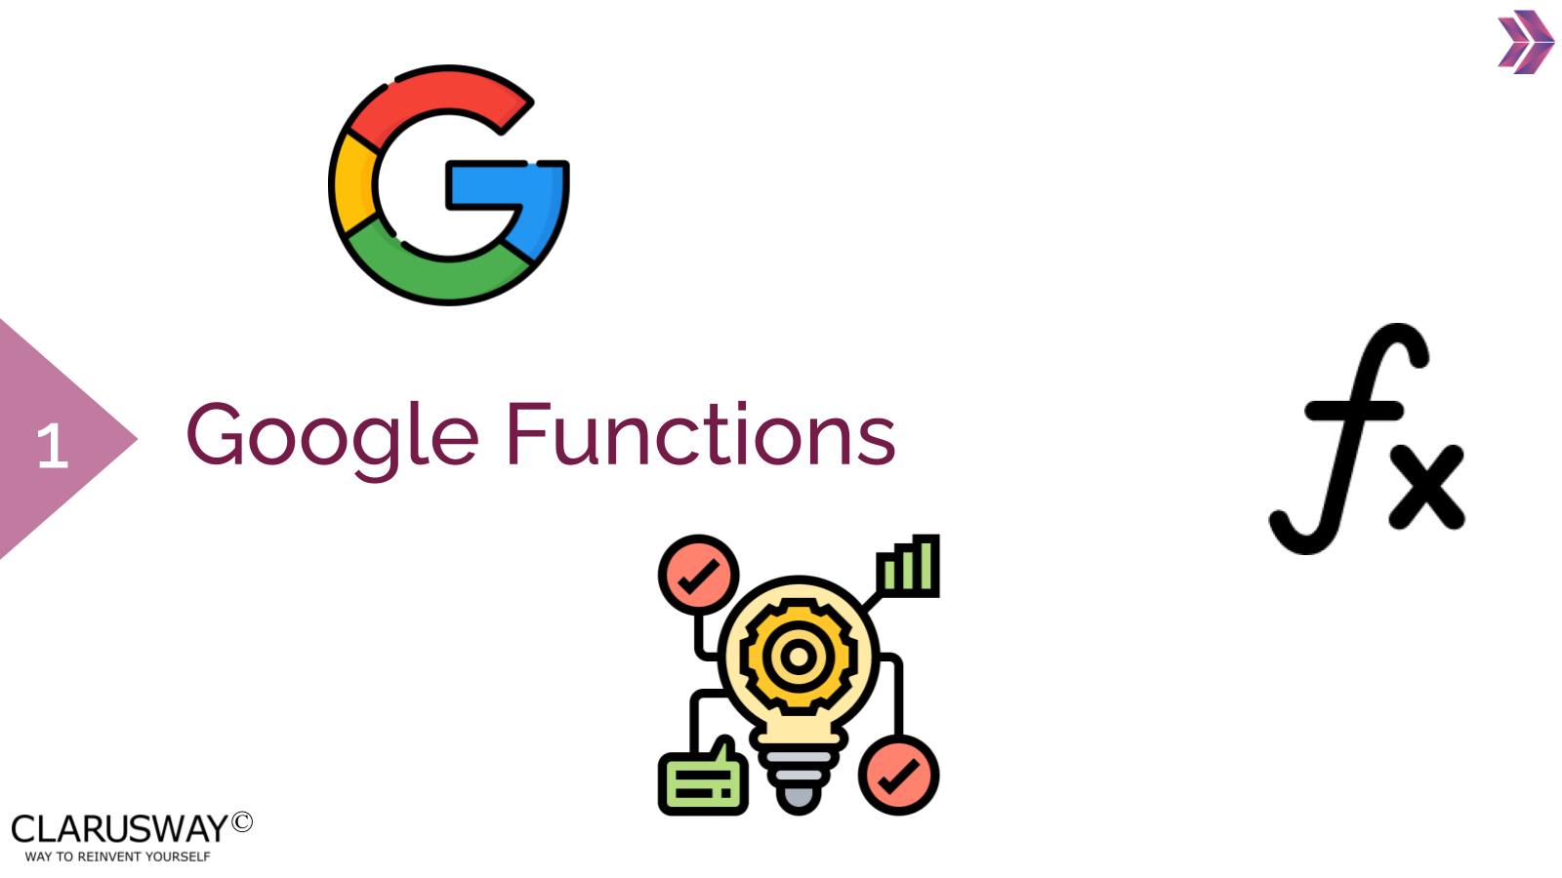

Use this space to take notes:

Slide 5
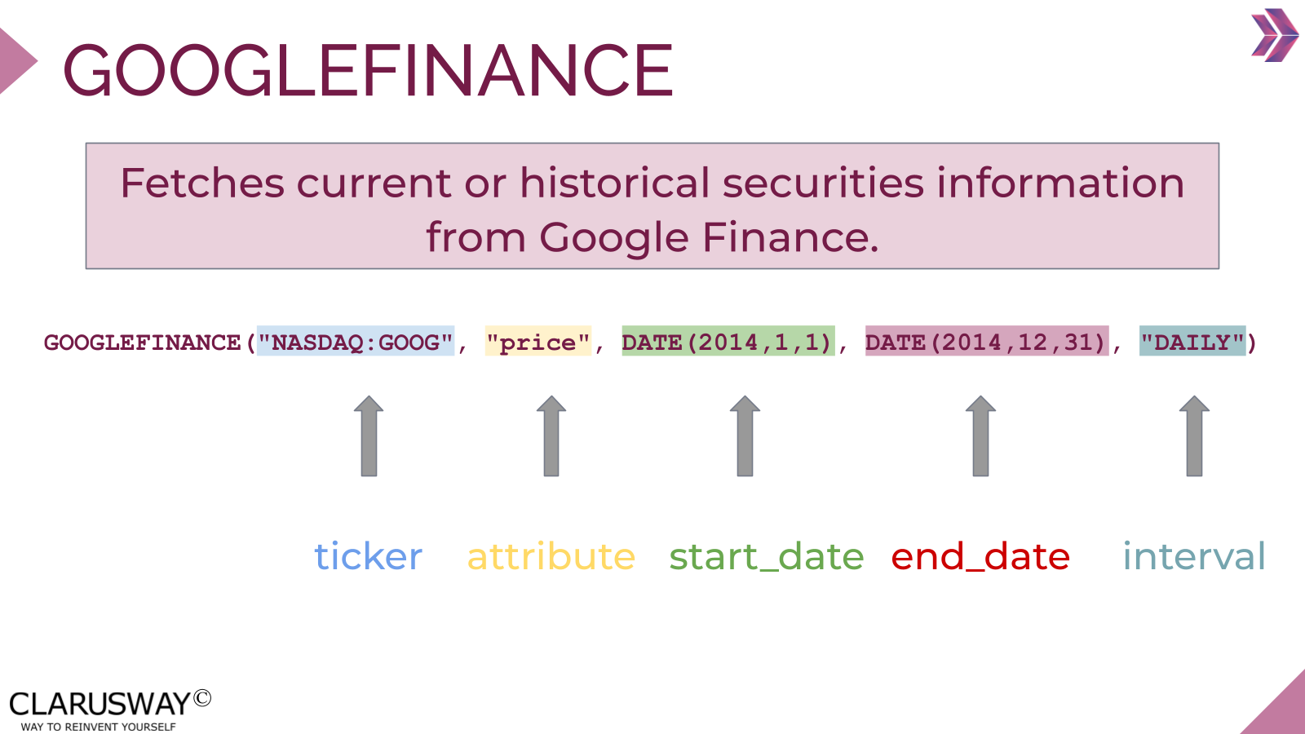

Use this space to take notes:

Slide 6
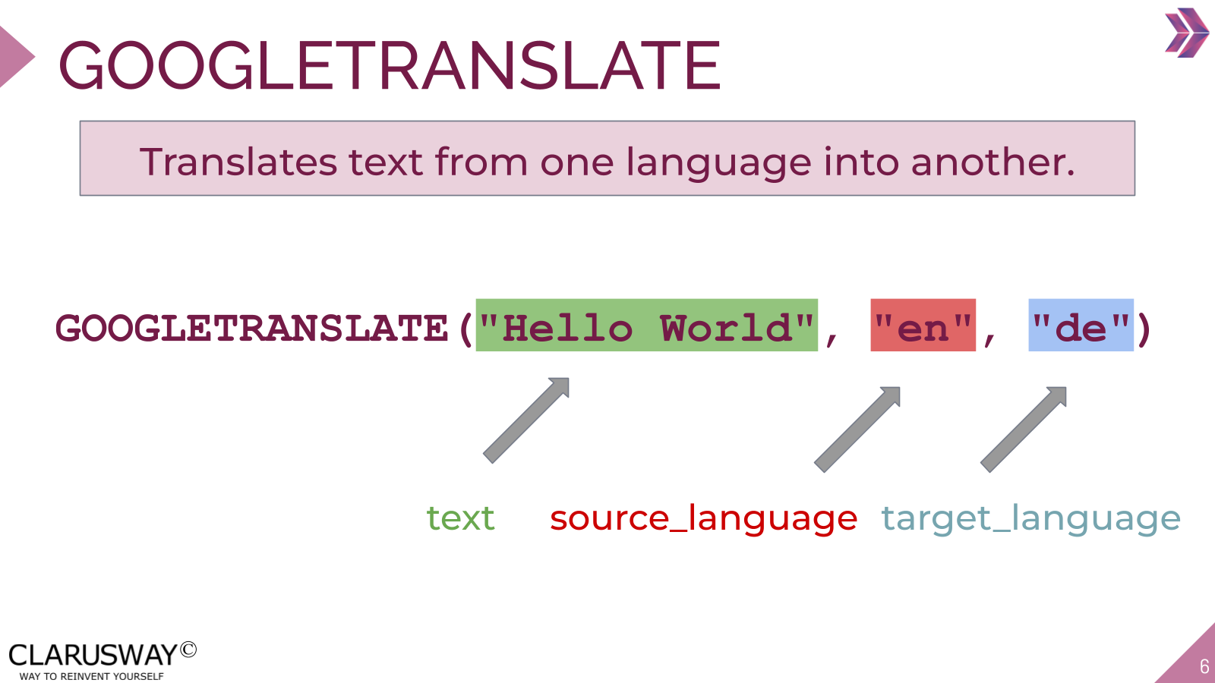

Use this space to take notes:

Slide 7
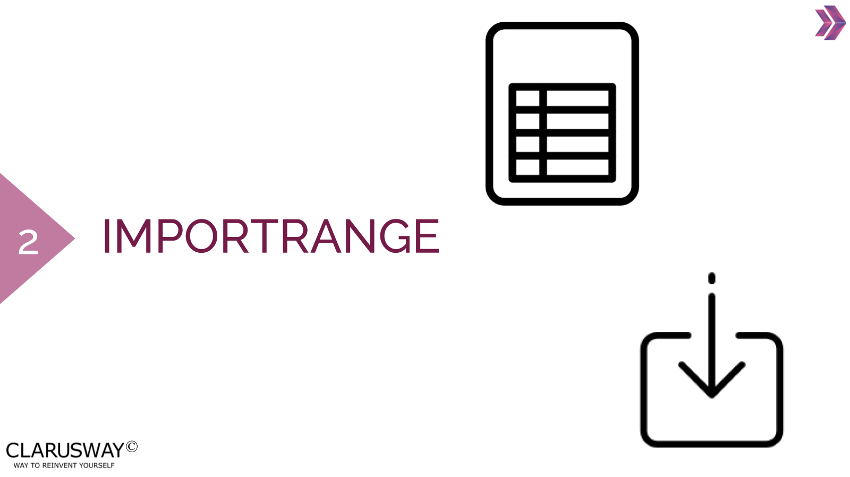

Use this space to take notes:

Slide 8
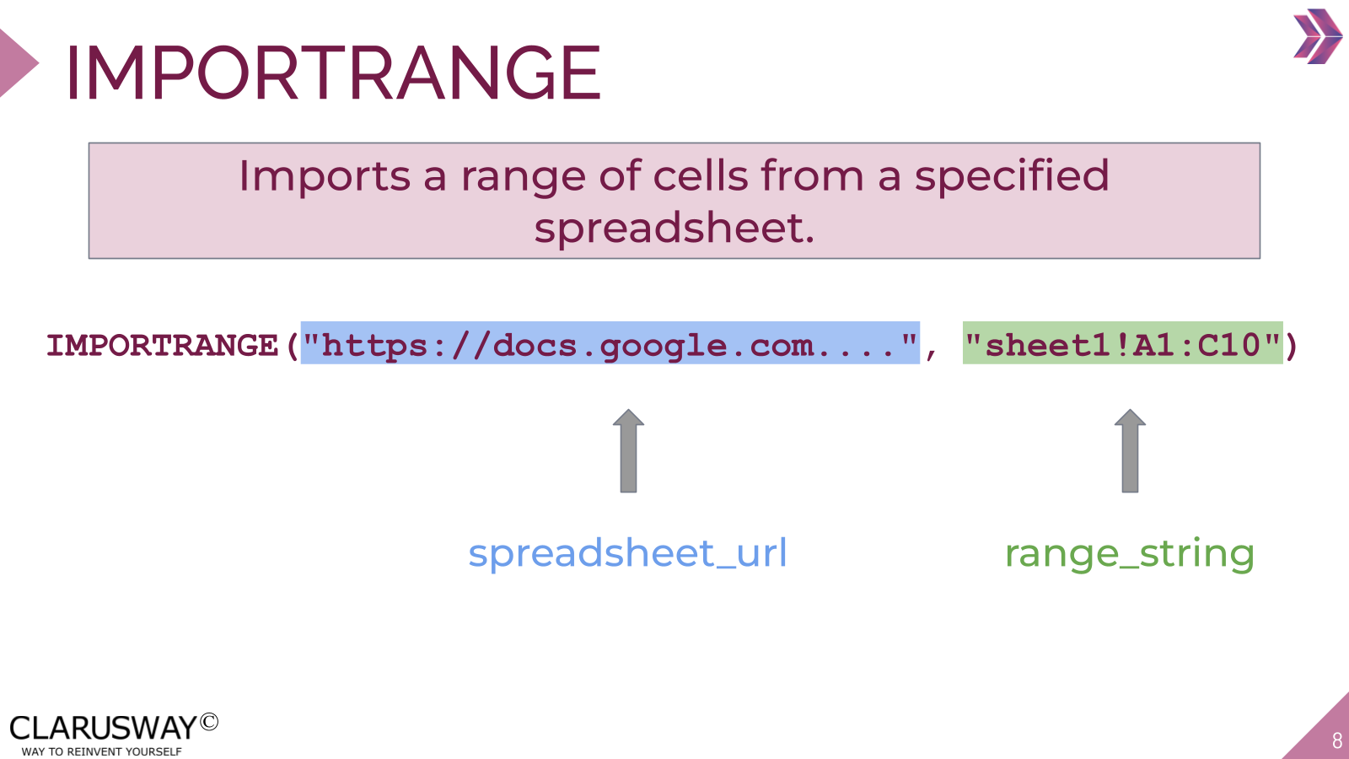

Use this space to take notes:

Slide 9
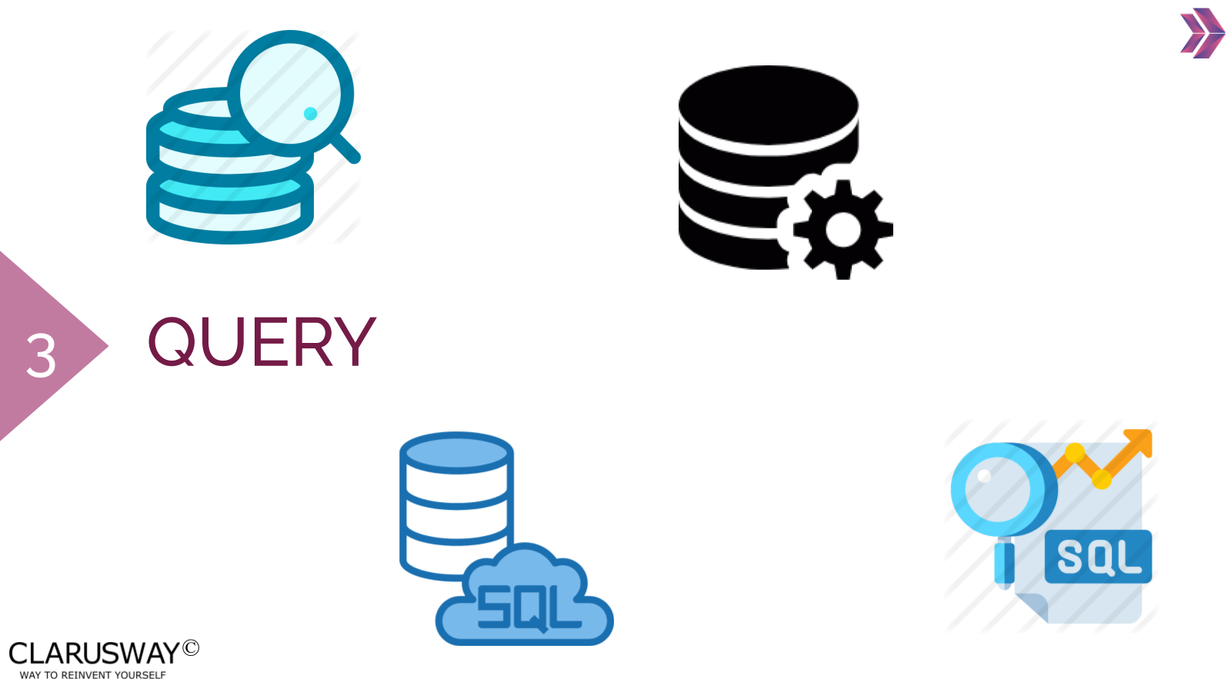

Use this space to take notes:

Slide 10
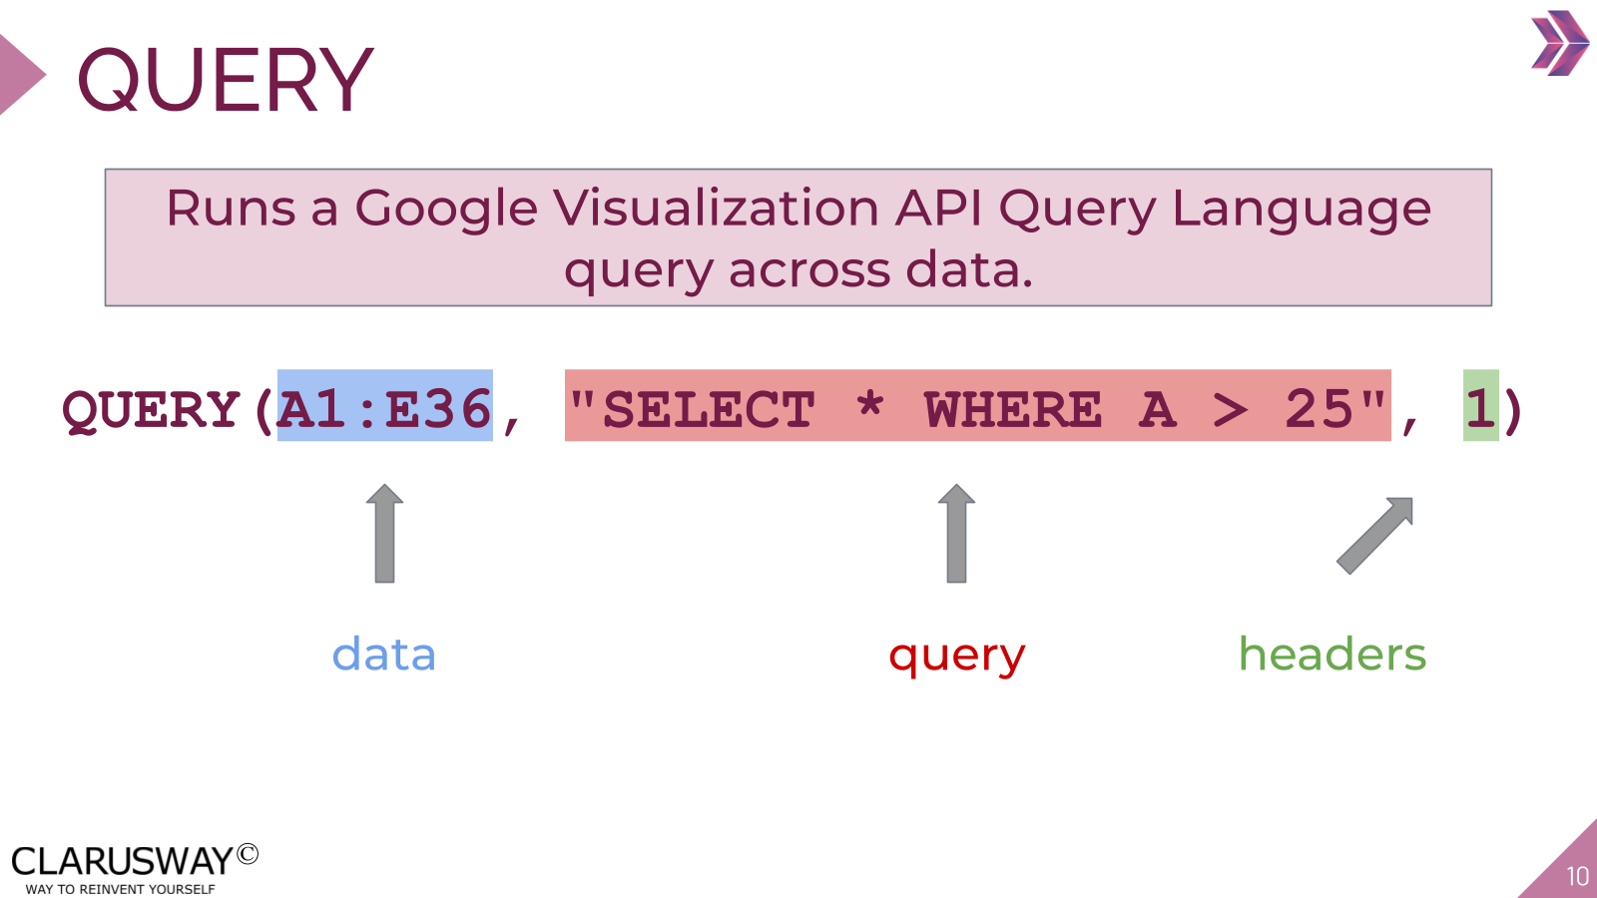

Use this space to take notes:

Slide 11
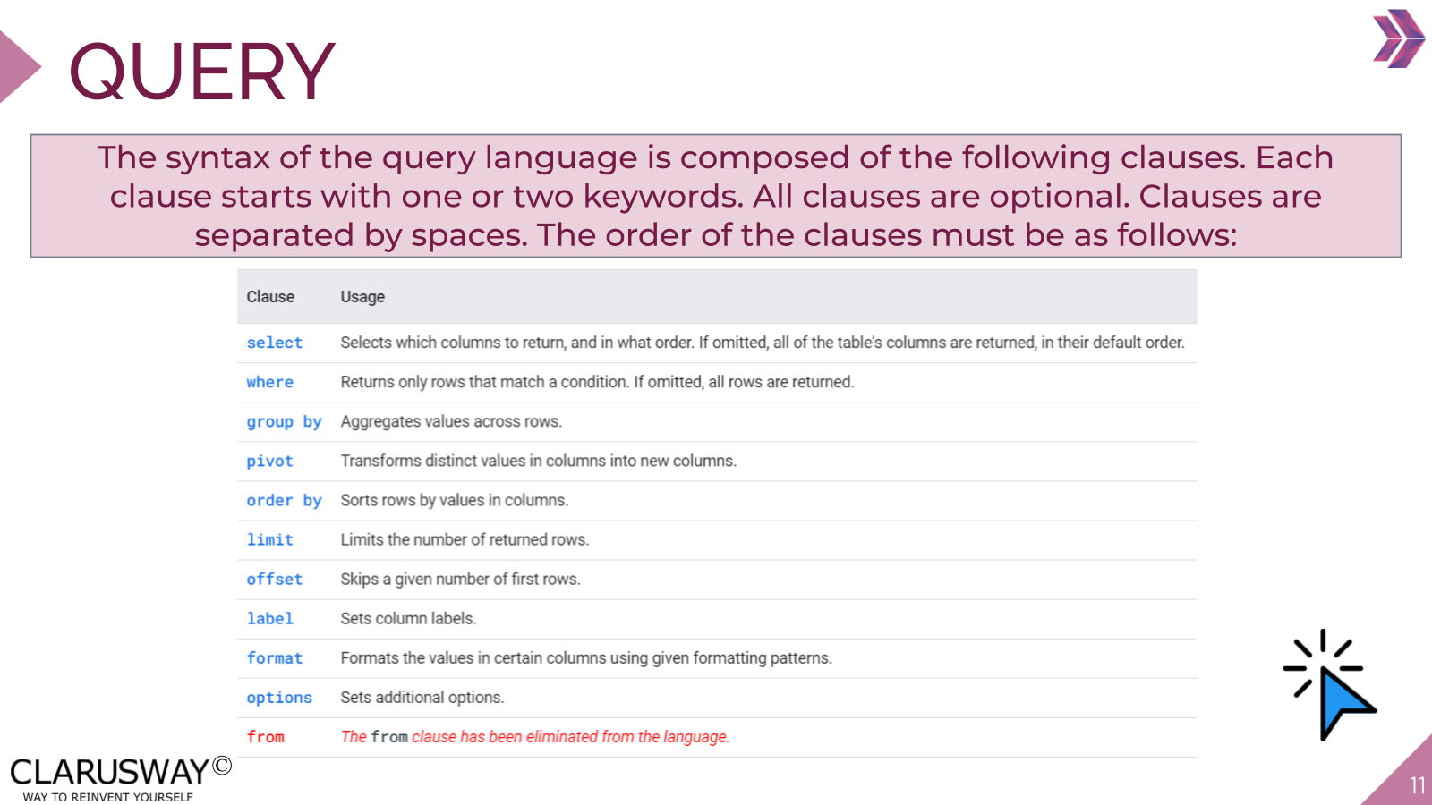

Link(s) on this slide:
- https://developers.google.com/chart/interactive/docs/querylanguage

Use this space to take notes:

Slide 12 | Your Response
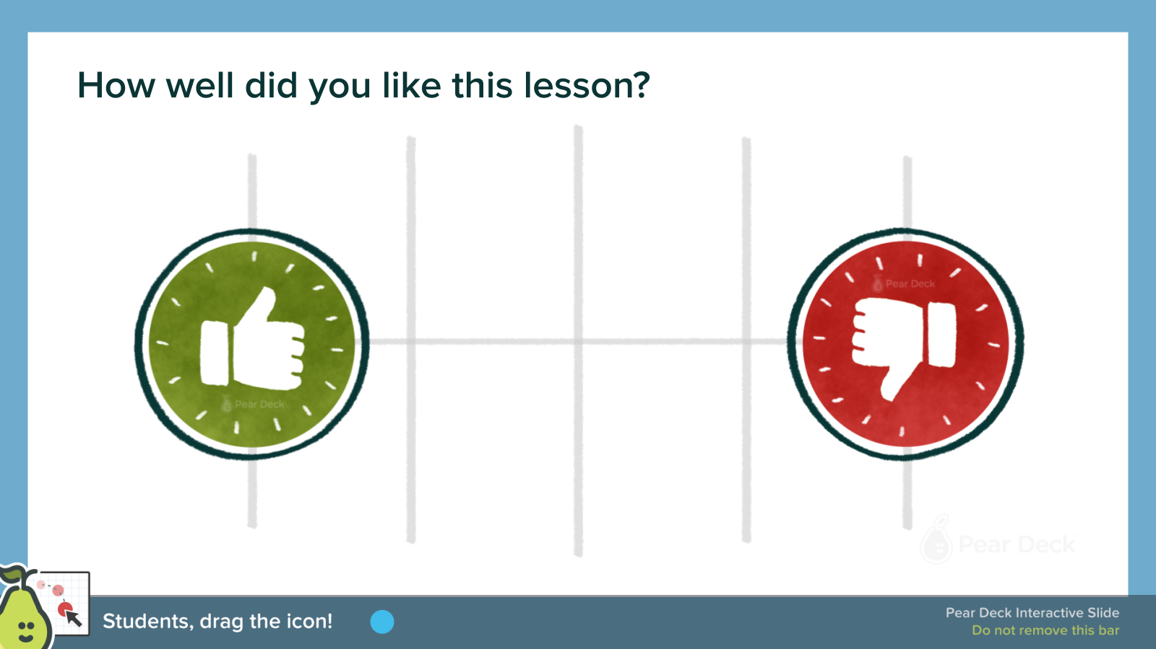 | 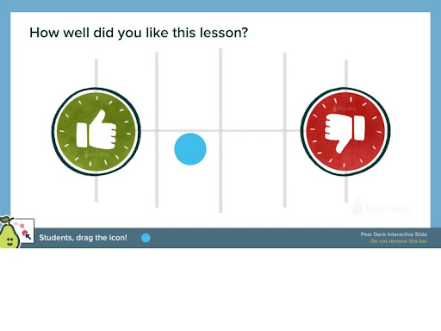
Use this space to take notes:

Slide 13
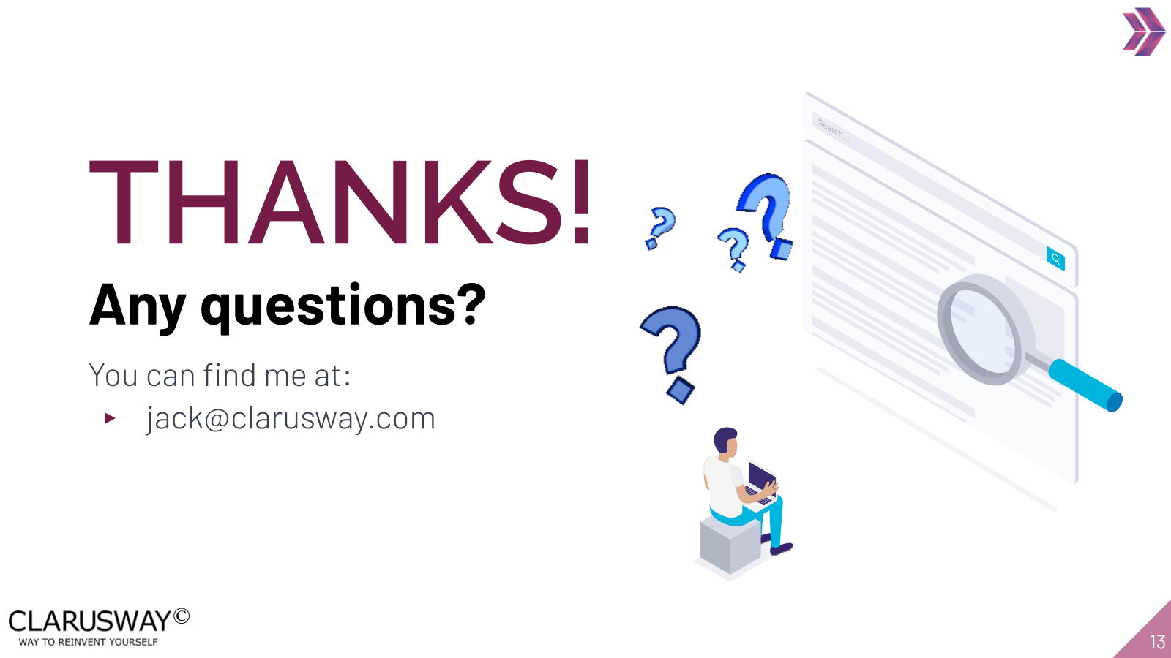

Use this space to take notes:

